How did you travel in your classroom?
Feedback tool to be used by mentor teachers, school coordinators or university liaisons.

- Draw classroom layout.

- Track the pre-service teacher to show him/her how s/he moves move around for the lesson or part of the lesson. Show both the travel path and the places where they stop to address students.

- Comments: Example:
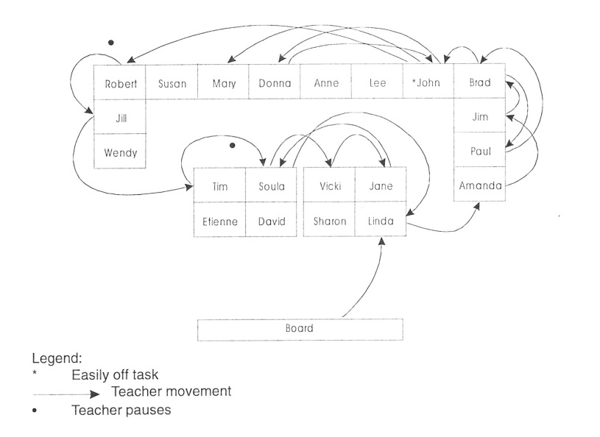
McBurney-Fry G 2002. Improving Your Practicum. Social Sciences Press,
Australia, p188.

